**STEM Outreach**

CS410 Capstone Project - PNNL

Last edited 1/24/2025

Alea Minar

In this document:

**Project Plan 3**

Management Plan 3

Team Organization 3

Work Division 3

Team Communication 3

Work Breakdown Schedule 3

Milestones 3

Project Schedule 3

Monitoring and Reporting 4

Implementation Plan 4

Steps 4

Intermediate Prototypes 5

Deliverables 5

**SDS 6**

Product Description 6

Design Description 6

Hardware 6

Hardware Rationale 6

Software 7

Diagrams 7

**SRS 10**

ConOps 10

Functional Requirements 10

Non-Functional Requirements 10

Technical Requirements 10

# Project Plan

## Management Plan

### Team Organization

* Alea Minar - Software Lead
* Hank Childs - Faculty Mentor
* Nick Cramer - Industry Mentor

### Work Division

Hardware:

* 3D printing
* Controls

Software:

* Python package
* Digital twin

### Team Communication

* Discord for general communication with Nick
* Email for general communication with Hank
* Meetings/Scrums

## Work Breakdown Schedule

### Milestones

* Simplified 3D model
* Initial 3D print
* Finished 3D model
* Finished print
* Working microcontroller
* Python + Digital twin representation

### Project Schedule

* ~~Contact MakerSpace about 3D printing - 1/15~~
* ~~Get account number from Hank - 1/23~~
* ~~Define requirements - 1/23~~
* ~~Plan project schedule - 1/23~~
* ~~Research what kind of hardware is necessary - 1/23~~
* ~~Order hardware - 1/27~~
* Create simplified 3-D model - 1/24 - 1/31
* Print 3-D model and ensure it meets size requirements - 2/3
* Create final 3-D model - 2/3 - 2/7
* Print 3-D model and ensure it meets size requirements - 2/10
* Implement the hardware - 2/17
* Write software necessary to match speed from hardware - 2/17
* Implement digital twin representation - 2/24
* Ensure documentation is up to date and create deliverable package for Nick - 3/3
* Discuss future check-in and sharing of project with Nick - 3/5

## Monitoring and Reporting

* Weekly class-wide scrums on Mondays
* Meetings with Faculty Mentor as needed
* Biweekly meetings with Nick to update
* Email and Discord updates as needed

## Implementation Plan

### Steps

1. Contact MakerSpace about 3D printing
2. Get account number from Hank
3. Define requirements
4. Plan project schedule
5. Research what kind of hardware is necessary
6. Order hardware
7. Create simplified 3-D model
8. Print 3-D model and ensure it meets size requirements
9. Create final 3-D model
10. Print 3-D model and ensure it meets size requirements
11. Implement the hardware
12. Write software necessary to match speed from hardware
13. Implement digital twin representation
14. Ensure documentation is up to date and create deliverable package for Nick
15. Discuss future check-in and sharing of project with Nick

### Intermediate Prototypes

* Initial simplified 3-D print to ensure correct measurements
* Finished 3-D print
* Digital twin representation

### Deliverables

* STL/Blender file of the generator model
* Sensor schematics/instructions; Arduino code for revolutions
* Code implementation of sensor and digital twin (Python)
* Project documentation

# SDS

## Product Description

## Design Description

### Hardware

**Link to an excellent tutorial:**

<https://makersportal.com/blog/2018/10/3/arduino-tachometer-using-a-hall-effect-sensor-to-measure-rotations-from-a-fan>

| **Required** | **Chosen** | **Purpose** |
| --- | --- | --- |
| Hall effect sensor | [A3144](https://www.amazon.com/gp/product/B00SWK15ZE/ref=as_li_qf_asin_il_tl?ie=UTF8&tag=engineersport-20&creative=9325&linkCode=as2&creativeASIN=B00SWK15ZE&linkId=91c071b369855f68642c3b6a87ab757a) | Detects magnetic field changes |
| Microcontroller | [Arduino Uno](https://www.amazon.com/gp/product/B01EWOE0UU/ref=as_li_qf_asin_il_tl?ie=UTF8&tag=engineersport-20&creative=9325&linkCode=as2&creativeASIN=B01EWOE0UU&linkId=4faf50757bd386d7bddef501d4fba06e) | Processes sensor pulses and calculates rotational speed |
| Magnet | [Neodymium magnets](https://www.amazon.com/Magnets-Multi-use-Refrigerator-Neodymium-Whiteboard/dp/B09V16WWGJ/ref=sr_1_5?crid=5ZS1Q29SUWR3&dib=eyJ2IjoiMSJ9.QrKM7ogT4ZP_jWqiIV-Z0-_C5LbI5OhZJllQ5c5Ye-Wpa3eP1HyNgqECVUyeORa-JkZjQvwqIgF_EvV19az6nojk3BhNWuCmSF0LMRMp3TkfOqKr_tcBi0_kve4scYHXihRvoRvuXCAx51d-PvlPPPsR2nFR0w5kq-LOl0_yWxDgJdOi2ebPTff8YmCtHAaCyWzh1f3-Wu0z7-dokRYC_spXyMnvIaxrXxCVIUCUrZg.z_Jeewa3nLhpoyI2l1vAj2xolD2k3Ay6gmE6oLibDSE&dib_tag=se&keywords=neodymium%2Bmagnets%2B5mm&qid=1737751090&sprefix=neodymium%2Bmagnets%2B5mm%2Caps%2C186&sr=8-5&th=1) | Create the magnetic field detected by the Hall sensor as the gear rotates |
| Breadboard | [Mini breadboard](https://www.amazon.com/WWZMDiB-SYB-170-Breadboard-Plates-Multicolored/dp/B09YXQJMTG/ref=sr_1_3?dib=eyJ2IjoiMSJ9.A-7iX8t_hCWYV80xlwMcTAWcvWMMuAsTrzTDDyeHbQzyddxKMEwDAk2WZhkUjTAWHd_hGAJQuzpF42qHcrg9l8Q3NPr-RF-gYZZ183yvnxLyutZF2eKxnODhilXBJKts8ZGQMVDaP2YIOFoB9MMOLUvSiCh5fG-BZoVbQgRwAmfafgB28BUmYmXrc1RBDLwT3eqSH0BONiR3kBeNJ8dpoBDoU39X9NtC0Gjs696hzLQ.jkcvnLY8npmLYKuHKPQSvrD8MxbsgRewtwbU9GExi74&dib_tag=se&keywords=mini+breadboard&qid=1737751132&sr=8-3) | Provides a platform for wiring components |
| 10k resistor | [10k resistor](https://www.amazon.com/Elegoo-Values-Resistor-Assortment-Compliant/dp/B072BL2VX1/ref=sr_1_6?crid=2GO9GXT6NQFQ5&dib=eyJ2IjoiMSJ9.uv_TZBZKnNhnmZJ_-Rv2_UO5Te-sWDfppWes397QRBjDk-l1mHXS2LvPCpAV8dd34aVID-mPwvFrdFkzIrWHq8mmgCQlnMyUx6iz0y7vbeBWfIIVcGiari8UMvdLCOFXS-MR1sBfo1DilVwtiJdsGK-3PIHnvojAwdRH5gBukVO_qRD_1kRhDEPmE_wMy4rWQijlDuGlM9Nw6odIiEQJPoeNVyXDojDXkYPdcAzH2FN24GHpE1br54DUDsYkaL-rtgnN9ErPDlDyg02BZaVjUpMJx_wPjXhgSYwPKxujdM69V8GswDGEC5CGCvbySB4L_ZbP07cZzd-ELXif-K2iVBbOJgUpq_4Ttn414Q5Ci7I.UC8NJ2zvBbYqxcOlRfptjkAgL9Cg_bpPtExzK7AqXAc&dib_tag=se&keywords=1%2F4W+1%25+Metal+Film+Resistor+Kit+RoHS+Compliant&qid=1737751306&s=industrial&sprefix=1%2F4w+1%25+metal+film+resistor+kit+rohs+compliant%2Cindustrial%2C132&sr=1-6) | stabilizes the Hall sensor's digital output |

**Total price (from Amazon): $40.25**

### Hardware Rationale

**A3144 Hall effect sensor:**

A3144 is a digital hall effect sensor that gives discrete outputs (“on” or “off”) and is a popular choice

**Arduino Uno:**

* Beginner friendly
* Widely available documentation
* Real-time processing
* Has features for RPM measurement

**Neodymium Magnets:**

Small neodymium magnets are ideal due to their strong magnetic field and small size.

### Software

TBD

## Diagrams

Youtube link for the current system: <https://youtube.com/shorts/8WicbS5K2uE?si=RDwOSEg-Mbh8U_tr>

Youtube link for a demonstration of digital twin and microcontroller:

<https://www.youtube.com/watch?v=9bG94OCl_Cw>

Diagram of a generator:

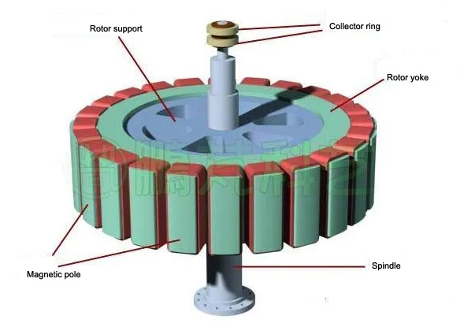

Image of a generator: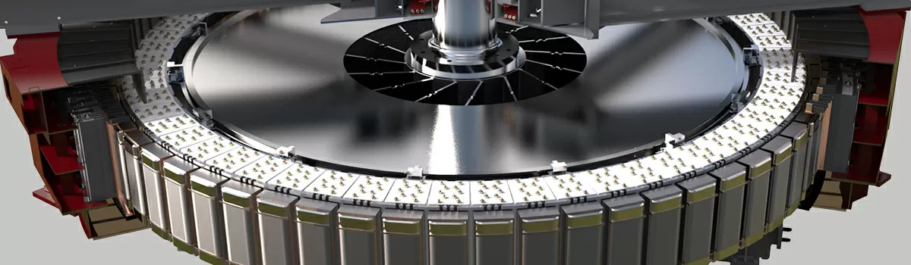Images of the base, top-down: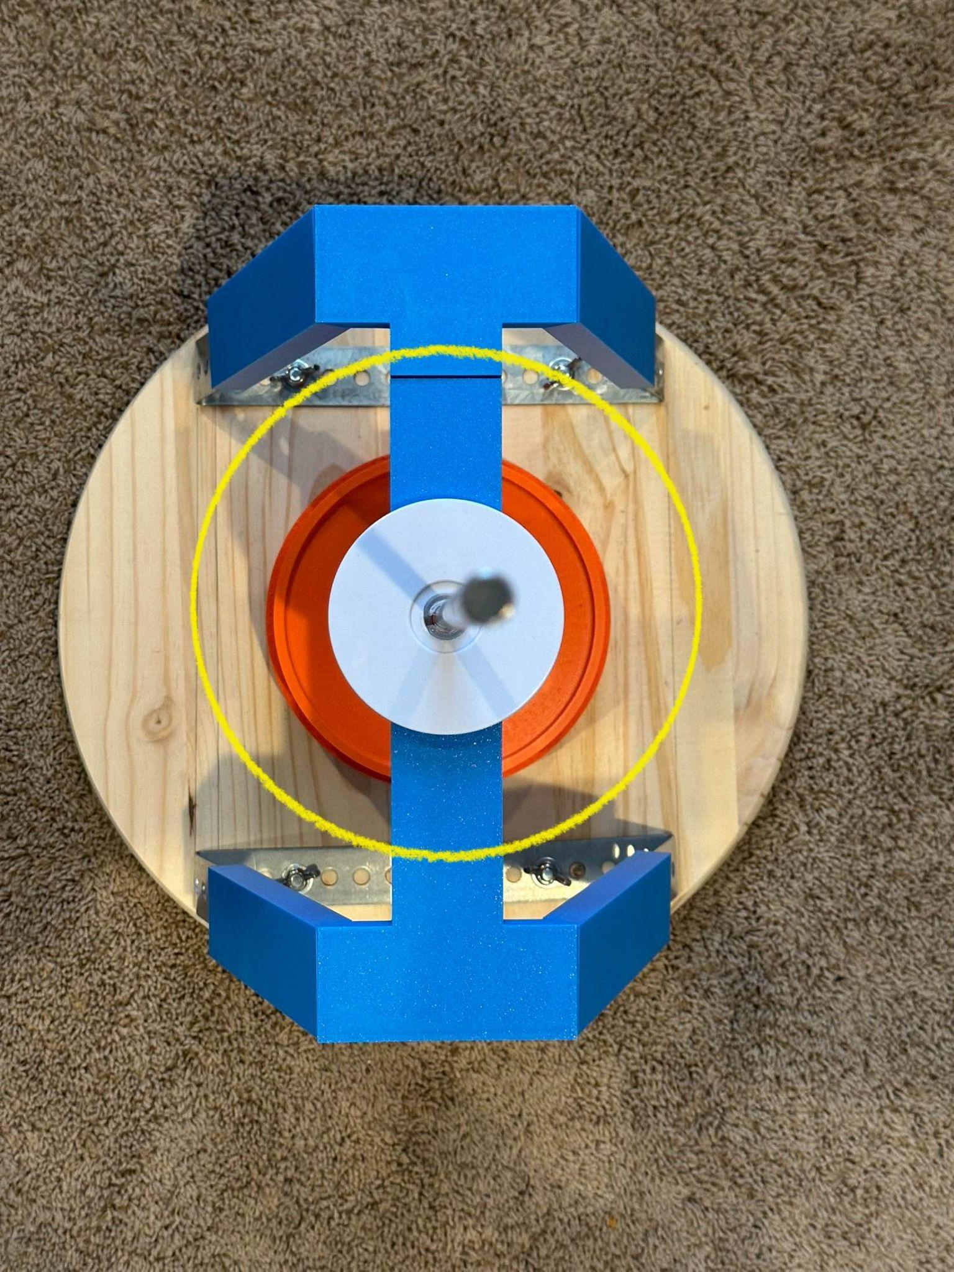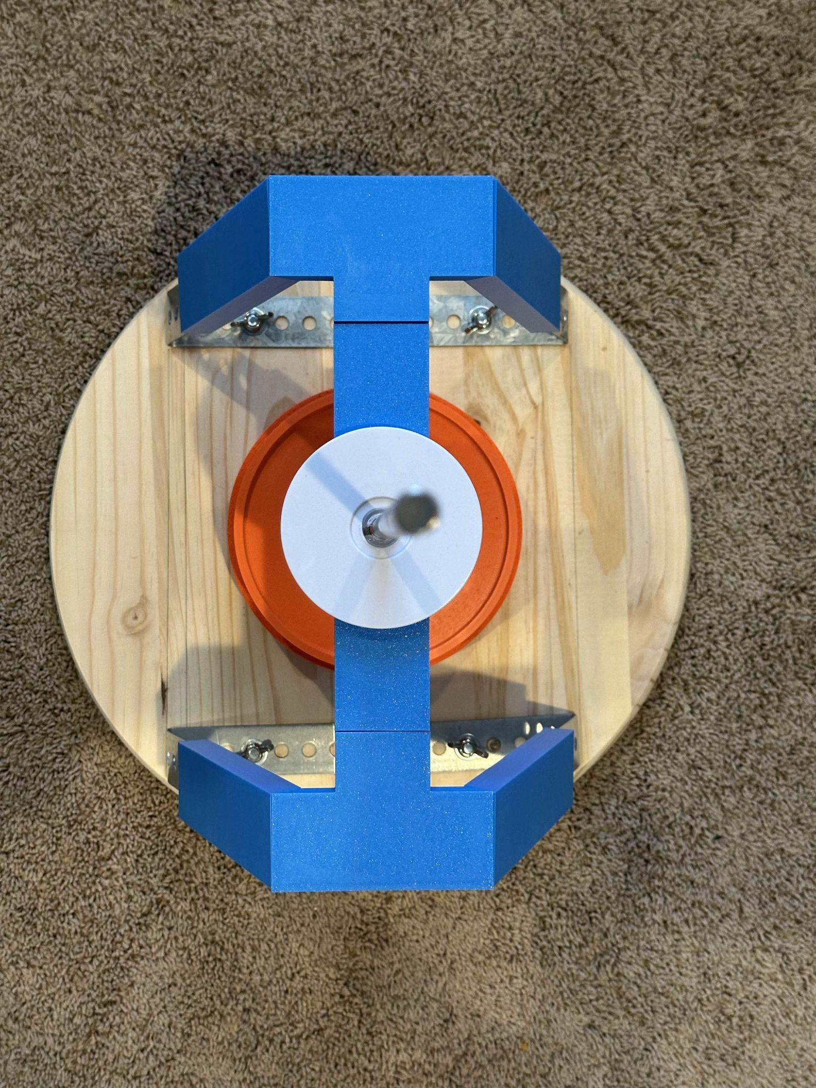

Images of the base detailing the measurements: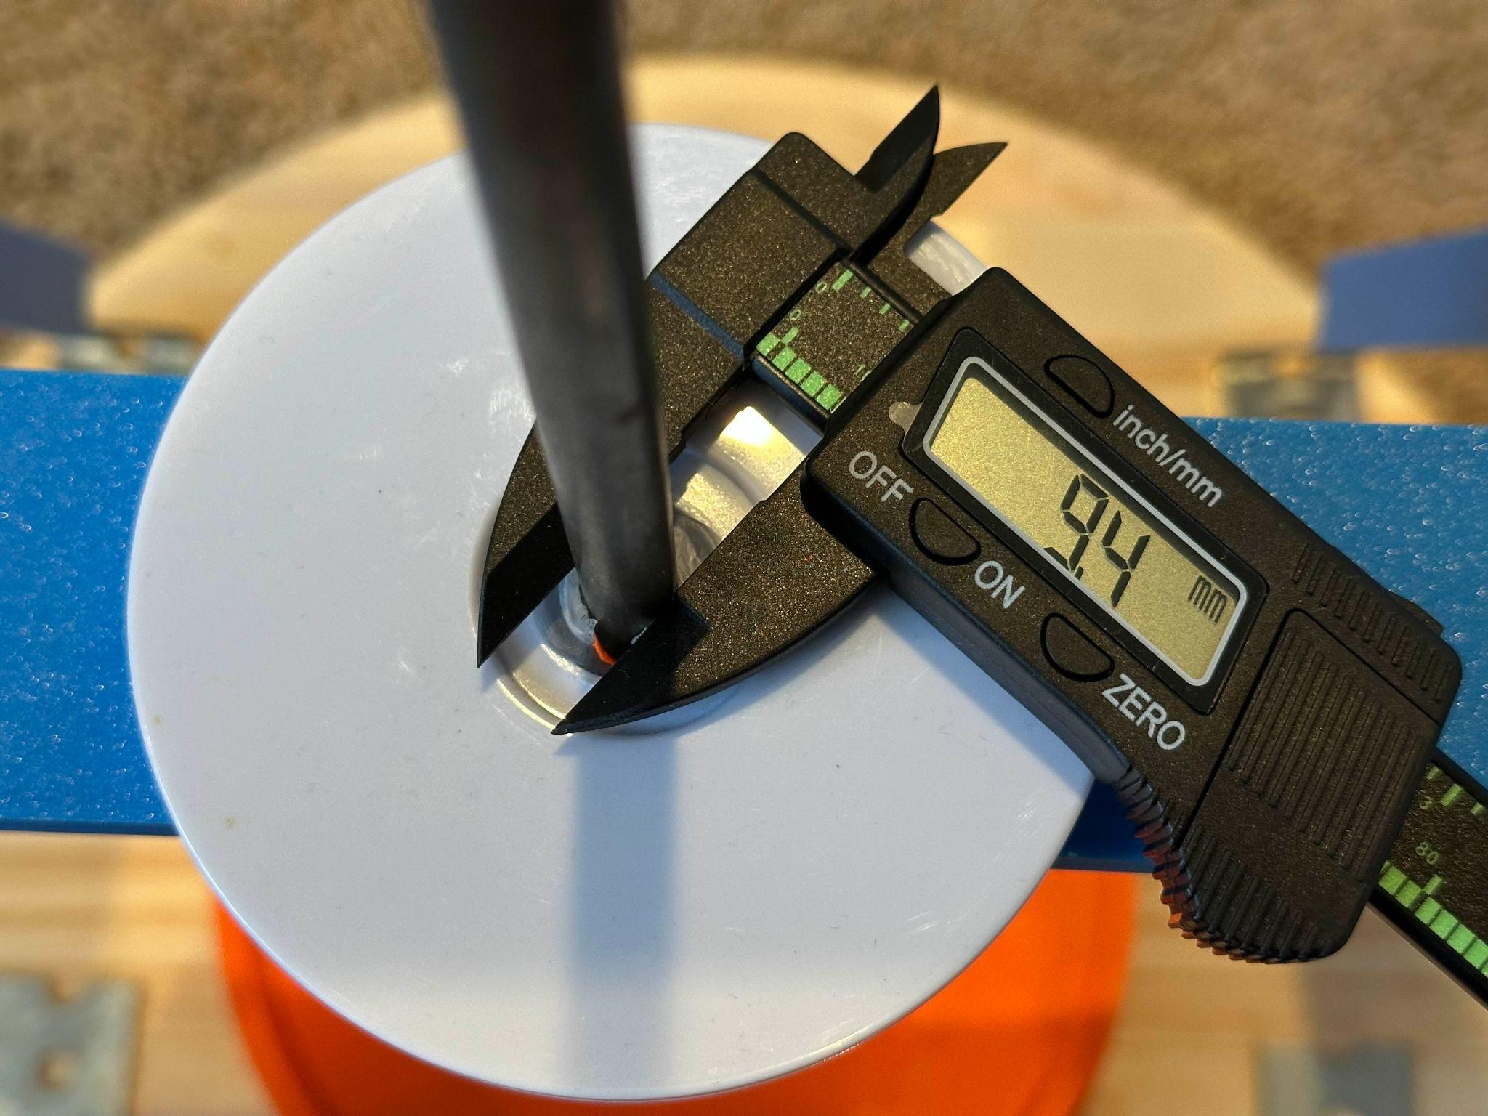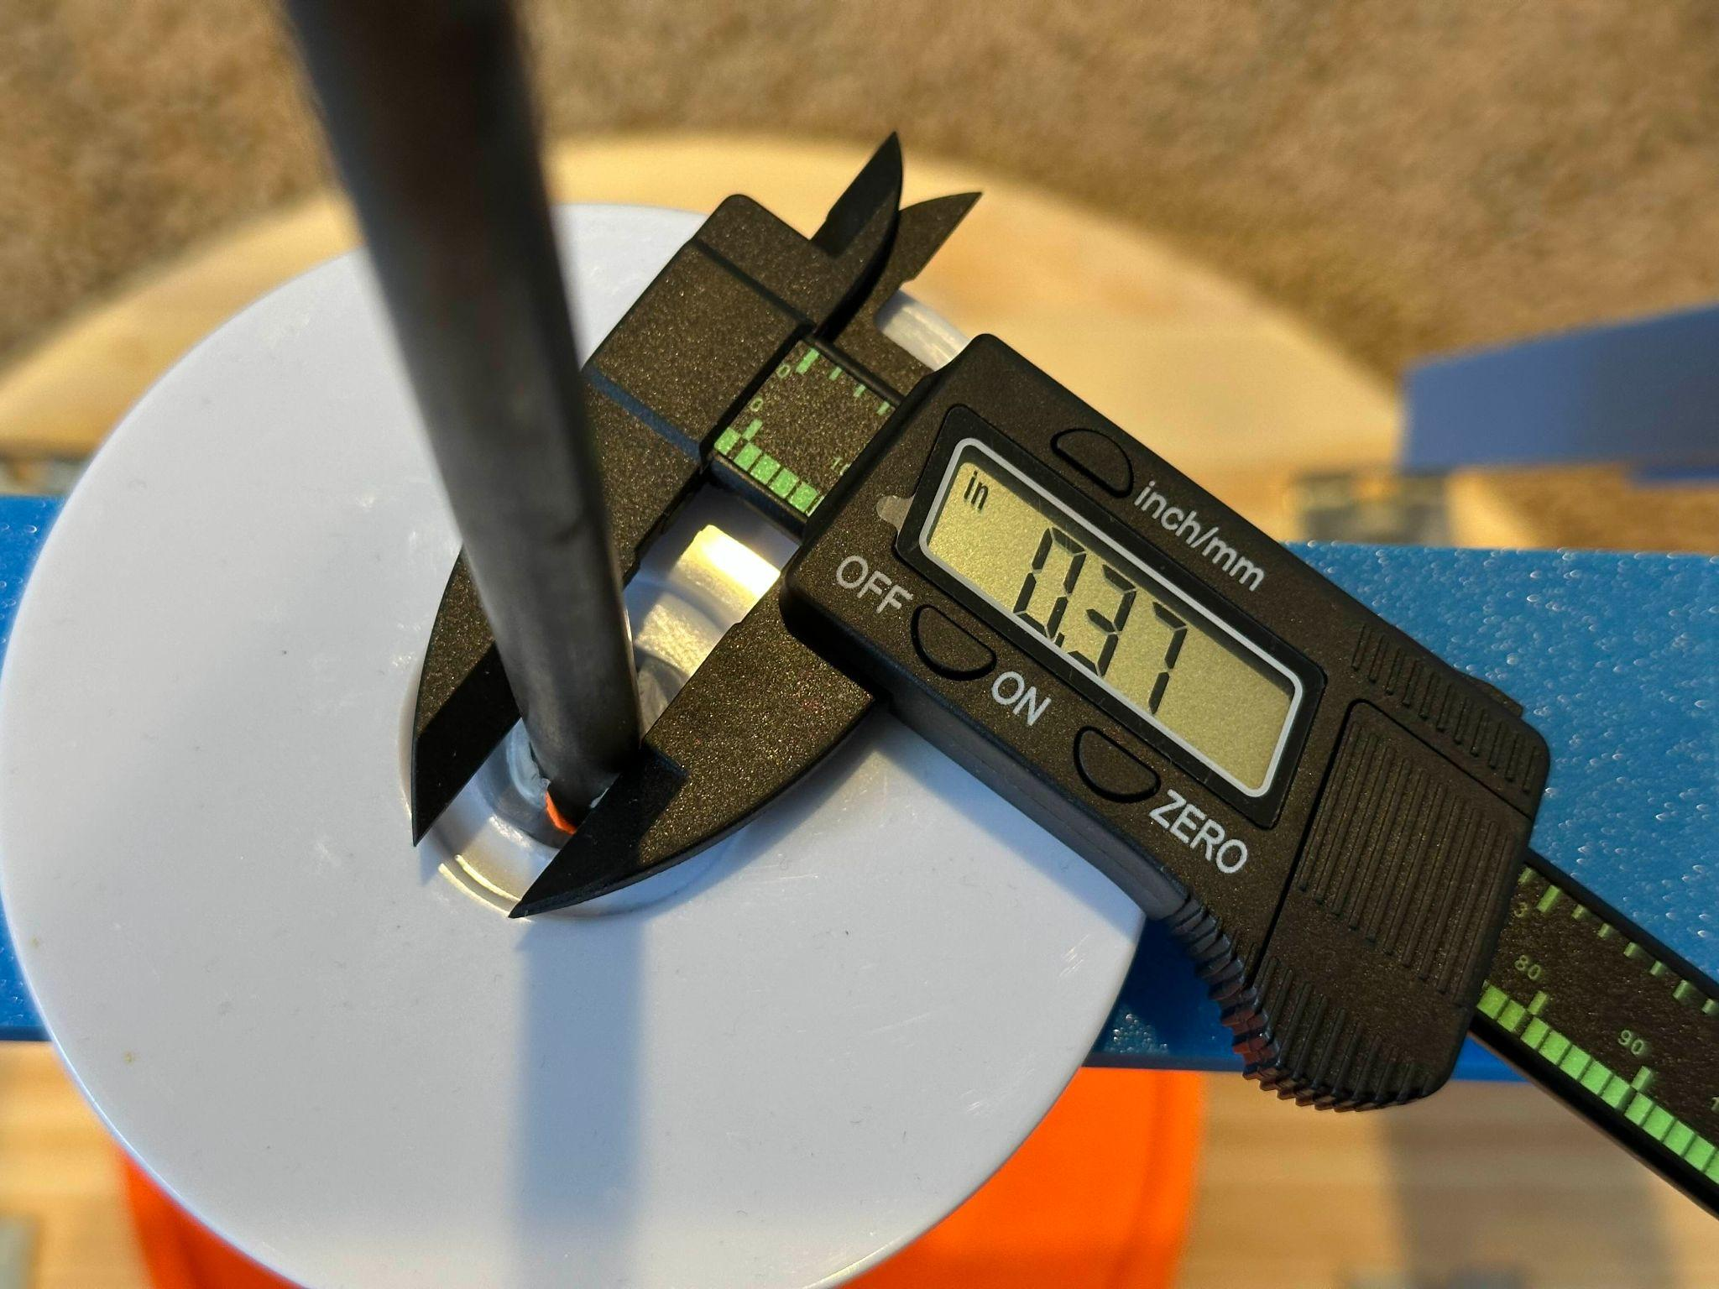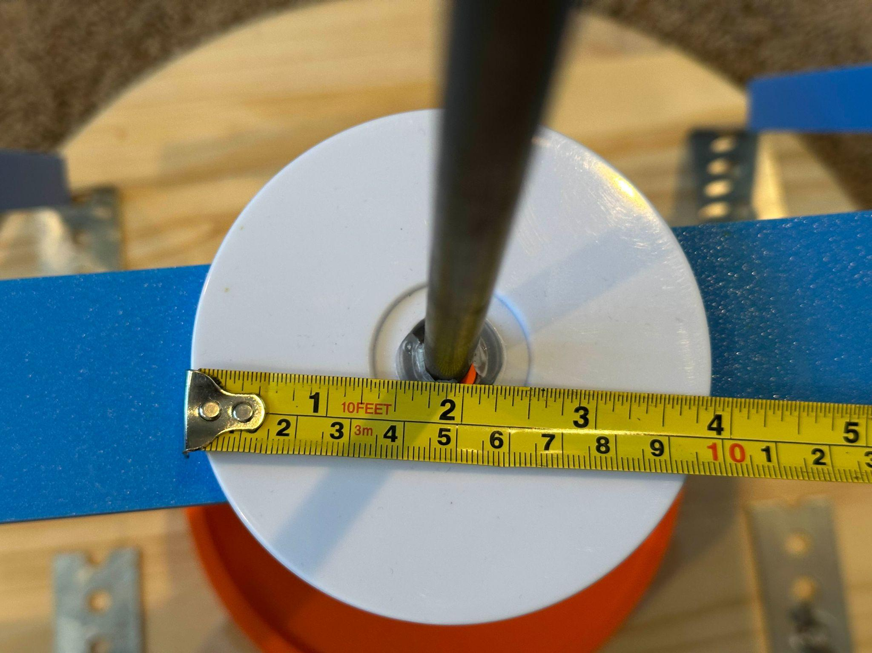

# SRS

## ConOps

## Functional Requirements

## Non-Functional Requirements

## Technical Requirements